| **Test Name** | Manually stop pump when pump is running |
| --- | --- |
| **Use Case Tested:** | Manually turn the pump off |
| **Test Description:** | This test verifies that the pump can be turned off using the manual on/off switch. |
| **Pre-conditions** | * Pump Running. * System State of Pump: Running. * ThingsBoard has not asked the pump to stop running via manual operation.. * Automation: Off. |
| **Post-conditions** | Running LED: Off  Manual Switch: Off  Transmit Status: Successful |
| **Notes:** |  |

|  | **TEST STEP** | **EXPECTED TEST RESULTS** |
| --- | --- | --- |
|  | Use the Dash to send a manual pump off message. | * Switch changes from on to off. * Transmit status becomes “In-Transit”. * Event Log shows Manual Off message. * Simulator receives the message. |
|  | Send Status from simulator | * Sim sends status message with pump still off. * Dash still displays “In-Transit. * Simulator changes it’s running flag to unchecked. |
|  | Send Status from simulator | * Sim sends status message with Pump Running flag off. * Dash displays Running LED as “Off”. * Transmit status displays “Successful”. |

|  |  |  |  |  |  |
| --- | --- | --- | --- | --- | --- |
| **Test Data Table** | | | | | |
|  | **1** | **2** | **3** | **4** | **5** |
| [Data field 1] | [data set 1 input value for field 1] |  |  |  |  |
| [Data field 2] | [data set 1 input value for field 2] |  |  |  |  |
| [Data field 3] | [data set 1 input value for field 3] |  |  |  |  |

**Results**

05/09/2020

**SUCCESS!**

Manual Off sent. Received. Updated.

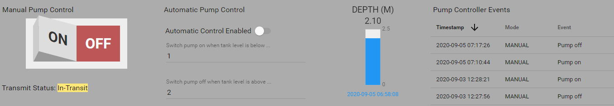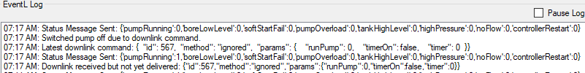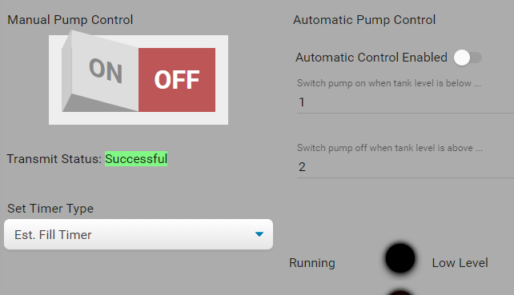

9/9/2020 – On site test at OAI.

Success.

Step 1.

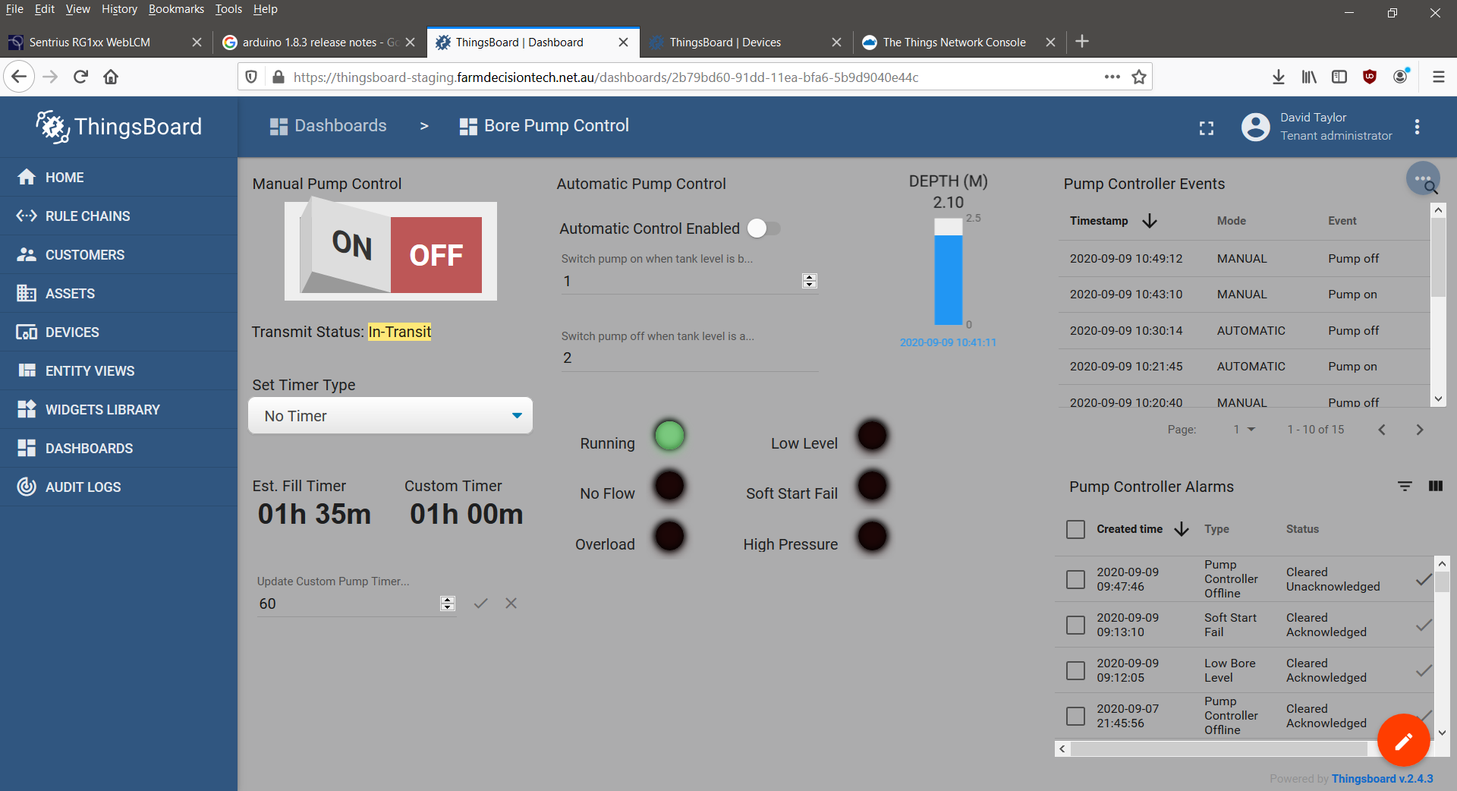

Step 2 & 3.

10:49:48.840 -> Send operator requested status message.

10:49:48.840 -> LoRaWAN will encode and send this message: {'pumpRunning':1,'boreLowLevel':0,'softStartFail':0,'pumpOverload':0,'controllerRestart':0,'highPressure':0,'noFlow':0}

10:49:48.840 -> Sending status byte: 01

10:49:49.931 -> EV_TXCOMPLETE (includes waiting for RX windows)

10:49:49.931 -> Received reply with 1 bytes:

10:49:49.931 -> 00

10:49:49.931 -> callback got data 0

10:49:49.931 -> Switched pump off.

10:49:49.931 -> Sending status due to state change.

10:49:49.931 -> LoRaWAN will encode and send this message: {'pumpRunning':0,'boreLowLevel':0,'softStartFail':0,'pumpOverload':0,'controllerRestart':0,'highPressure':0,'noFlow':0}

10:49:49.931 -> Sending status byte: 00